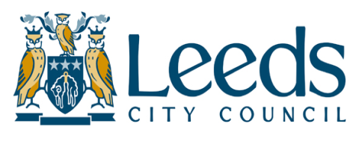
Application Form for Free School Meals

Only complete this claim form if have one or more children attending a School or Academy in Leeds (whether you live inside or outside the Leeds boundary).

Parents or carers who live in Bradford, Kirklees, North Yorkshire and Wakefield but have children who attend a school or Academy in Leeds must make their Free School Meal claims directly to Leeds City Council.

If you wish to claim help with your rent and/or Council Tax for an address in Leeds you should complete the full Leeds City Council benefits application form. This will also allow you to claim Free School Meals. These claim forms are available from any One Stop Centre or by telephoning the Benefits Helpline on 0113 2224404

Do not use this form to claim for children who attend schools or Academies outside Leeds. Applications for these children must now be made to the Local Authority in which their establishment is located.

DO I QUALIFY FOR HELP?

You can claim Free School Meals for any child who normally lives with you and who is classed as being under your parental care. To get Free School Meals you must receive one of the following benefits:

- Universal Credit, Income Support, Guarantee Credit, Income-based Job Seekers Allowance, Income-related Employment Support Allowance, Working Tax Credit Run-On and Child Tax Credit ONLY where your Annual Taxable Income does not exceed £16,190.
- If you get any amount of Working Tax Credit apart from Run-On you do not qualify for help.

WHICH CHILDREN GET FREE SCHOOL MEALS?
You can claim Free School Meals if you have any children in your care who attend a non-fee paying school full-time. This includes Academies and Free Schools, those in the sixth form (except Notre Dame and Elliott Hudson Sixth Form Colleges), those attending Pupil Referral Units and Specialist Inclusive Learning Centres and those below Reception age who have full day places at nurseries attached to an LEA maintained school (that is they attend nursery both before and after lunch). We will notify the schools of your child’s Free Meals entitlement- all you need to do is advise the school when you want to start taking them up.

HOW DO I FILL OUT THIS FORM?
Simply complete the questions on the other side of this sheet, making sure that you give us the following details: - your name, address and daytime telephone number, details of yourself and your partner including both your National Insurance Numbers, and details of all children under your care who attend schools or Academies in Leeds, including the name of each establishment. Please do not include any child who attends a school outside Leeds. Next, tell us which of the qualifying benefits you receive. We will verify your eligibility using the Government’s secure ECS website. If we are unable to determine entitlement using this service, we will write to you to request paper proof of benefit. Finally, read and sign the declaration at the end. If your claim is successful, your child's school will also benefit financially

WHERE DO I SEND IT?
Once you have filled in the form, please hand it back at your child’s school. Alternatively you can return it to any Council One Stop Centre in the city or post it to us directly at the following address:

Welfare & Benefits (FSM Claims)
Room 68
Hough Top Court
Leeds
LS13 4QP

If you need to speak to us about your claim or want to advise us of a change in your circumstances you can telephone us on 0113 2224404.

Application Form for Free School Meals
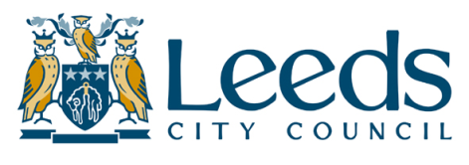 |  |  | For office use only
 |  |  | Claim number
 |  |  | Date issued
 |  |  | Date returned
Your name and address |  |  | Date returned
 |  |  | (Office stamp)
Your phone number |  |  | (Office stamp)
You do not have to tell us your phone number if you do not want to, but it will help us to contact you quickly if we have a question about your claim. |  |  | (Office stamp)

Please give details below about you and your partner.

 |  | First Names |  | Surname |  | D.O.B. |  | N.I. Number
You
Your partner
Please list below all the children who normally live with you and attend schools within Leeds. List the children in age order, the oldest first. Do not list children who attend schools outside Leeds
 | First Names |  |  | Surname |  | D.O.B. |  | Name of Leeds School
1st child |  |  |  |  |  | / /
2nd child
3rd child
4th child
5th child

Please state in the box below which of the following qualifying benefits you are currently in receipt of (eg Universal Credit, Income Support, Pension Guarantee Credit, Income-based Job Seekers Allowance, Income-related Employment Support Allowance, Working Tax Credit Run-On or Child Tax Credit). We will check your eligibility via a secure government website.
Please read the statement below and then sign and date the form

• This is my claim for Free School Meals ONLY.
• I declare that all the information I have given is correct and complete to the best of my knowledge.
• I authorise Leeds Welfare & Benefits Service to make any necessary enquiries to verify the details I
have provided and to cross check them with other council departments, councils and benefit authorities.
• I understand that if I give information which is incorrect, or fail to report any changes which may affect
my entitlement to benefit I may be prosecuted.
• I am aware that I have a duty to notify Leeds Welfare & Benefits Service in writing immediately of any
changes in my circumstances which might affect my entitlement to Free School Meals, including change
of income, change of address or change of school.
• I understand that the information I have provided on this form may be used by Leeds City Council to
prevent and detect fraud.

Signature of person claiming |  |  |  | Date

